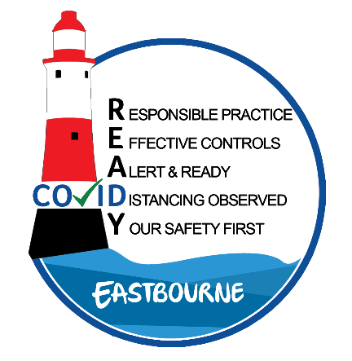
Supported by:
COVID R.E.A.D.Y Risk Assessment
Developed in association with Primary Authority
.
** Subject to Guidance Update & Change. Click here for updates.

Hospitality Sector: | RESTAURANT DINE-IN

Assessment Details
Membership Organisation: |  |  | Click here to enter text. |  |  | Date: |  |  | Click here to enter text.
Business Name: |  |  | Click here to enter text. |  |  | Address: |  |  | Click here to enter text.
Click here to enter text.
 |  |  |  |  |  | Post Code: |  |  | Click here to enter text.
Insurance Certificate: |  | ☐ | Gas Safety Certificate: |  | ☐ | Fire Risk Assessment: |  |  | ☐ | CO Detectors: |  |  | ☐
Completion Guide:
The example below demonstrates how this Risk Assessment works. Give the Severity (S) and Likelihood (L) a score based on the table below. Multiply (S) by (L) to create a risk score (R).
Score each job hazard rather than each control measure.
Severity (S): | 6 Multiple Deaths | 5 Single Death | 4 Major | 3 Lost Time Injury | 2 Minor | 1 Delay
Likelihood (L): | 6 Certain | 5 Very Likely | 4 Likely to Happen | 3 May Happen | 2 Unlikely to Happen | 1 Very Unlikely to Happen

The figures will give a risk score between  0 and 36:  0-10 low risk (Green)  11-20 medium risk (Amber)  21-36 high risk (Red) |  | 0-10 | Green  Low Risk |  | 11-20 |  | Amber  Medium Risk |  |  |  | 21-36 |  | Red  High Risk
Focus should be placed on any high-risk areas and where risk can be mitigated.
Job Hazard Exposure / Detailed Hazard | Possible Harm  and Effects |  |  | Existing  Control Measures |  |  |  | Recommended Controls / Information  (In Priority Order) |  |  |  | S |  | L | R
EXAMPLE  Person to person contact while ordering / collecting / delivering food / drinks during COVID 19 pandemic | Becoming infected with COVID-19 and further spread the infection |  |  | Encouraging single use menus for ordering |  |  |  | Disposable after single use |  |  |  | 4 |  | 2 | 8

Job Hazard Exposure / Detailed Hazard | Possible Harm  and Effects | Existing Control Measures/Action /By whom |  |  | Recommended Controls / Information  (In Priority Order) | S | L | R
Point of Entry  Person to person contact | Becoming infected with COVID-19 and further spread the infection | Click or tap here to enter text. | Click or tap here to enter text. | Click or tap here to enter text. | Staff  Staggering arrivals  Covid-19 Specific Training - documented  Relevant PPE provision  Minimising mixed teams – form ‘work bubbles’  Fit for Work questionnaire documented  Distanced Workstations  Guests  Staggered & time-sensitive booking slots (i.e. 1.5hr)  Queuing maintains social distancing @ 2m  Online or telephone booking procedure | Click here to enter no. | Click here to enter no. | Click here to enter no.
Social Distancing Measures  Person to person contact | Becoming infected with COVID-19 and further spread the infection | Click here to enter no. | Click or tap here to enter text. | Click or tap here to enter text. | Staff  Allocated separate workstations  Covid-19 Specific Training - documented  Guests  Staggering booking slots  Posters with guidelines  Table dividers - planters  2m from seat to seat on next table  Remove un-used tables  Time-controlled slots of 1.5hrs  Floor markings for guidance  One-way system if possible  Card payment only where possible

Job Hazard Exposure / Detailed Hazard | Possible Harm  and Effects | Existing Control Measures/Action /By whom |  |  | Recommended Controls / Information  (In Priority Order) | S | L | R
Used tables/surfaces/workstations | Becoming infected with COVID-19 and further spread the infection | Click or tap here to enter text. | Click or tap here to enter text. | Click or tap here to enter text. | Disinfecting all surfaces more often & robust cleaning schedule in place.  Disinfecting tables & chairs after each use.  Additional disinfection of tables/chairs after each use.  Use of disposable menus.  Disinfecting kitchen stations.  Documented WC Cleaning.  Returned dirty crockery/glassware to be handled separately and washed at over 60 degrees – no food handlers to handle ‘used’ items.  Staff  Training provided and documented.  Frequent hand washing, best practice.  Guests  Posters and Hand Washing recommended | Click here to enter no. | Click here to enter no. | Click here to enter no.

Job Hazard Exposure / Detailed Hazard | Possible Harm  and Effects | Existing Control Measures/Action /By whom |  |  | Recommended Controls / Information  (In Priority Order) | S | L | R
Track & Trace Support | Becoming infected with COVID-19 and further spread the infection | Click or tap here to enter text. | Click or tap here to enter text. | Click or tap here to enter text. | Staff  Fit to work daily assessment, temperature taken on arrival.  Training Provided.  Guests  Data gathering with each lead guest taken at booking or when entering restaurant.  Contact tracing procedures actioned and retained for minimum 21 days. | Click here to enter no. | Click here to enter no. | Click here to enter no.
Deliveries In/Out | Becoming infected with COVID-19 and further spread the infection | Click or tap here to enter text. | Click or tap here to enter text. | Click or tap here to enter text. | - Check with all your external delivery companies what their updated social distancing procedures are and how does that affect your business.  - Trained staff only to receive goods in, in appropriate PPE  - Less deliveries/ different time of deliveries.

COVID READY is part funded by the European Regional Development Fund via the Reopening High Streets Safely Fund

